Shanghai Tuscan Lodge 1027 Donation to Bromley Mencap

Shanghai Tuscan Lodge 1027 donated the funding to enable Bromley Mencap to purchase and install an irrigation system at their Lodge, located in Norman Park on Bromley Common. With the current pandemic, it is ensuring all their plants continue to be watered, and they hope to have their students managing the crops as soon as possible.
Bromley Mencap were able to install the irrigation system with the help of some volunteers, and it is now fully operational. They have two systems running, off separate timers. One provides a loop through the poly tunnel and another provides a loop around the 4 raised beds in the garden. They were also able with the donation to purchase two water butts, one for each end of the garden which will also be hugely beneficial for the students.
Caroline Stone – Head of Adult and Children Services, Bromley Mencap commented “We’d be delighted to show you the system in action, when we are able to meet up again, but in the meantime, please can you pass on our thanks for the kind donation – we really do appreciate it. Our students would be very happy to show you around and tell you about the work they do at the Lodge.”

Pictures of the equipment purchased with the donation from Shanghai Tuscan Lodge 1027.
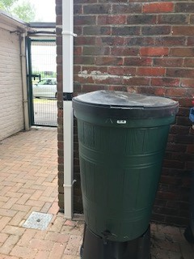 | 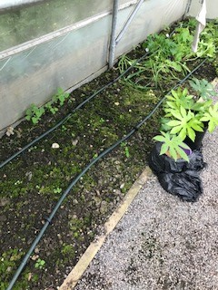 | 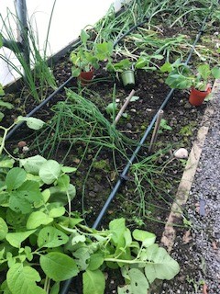 | 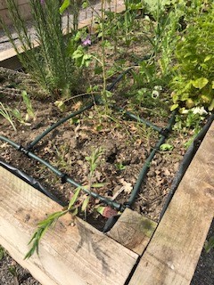
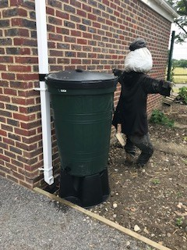 | 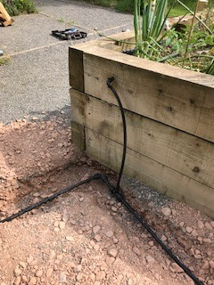
Bromley Mencap is an award winning charity, supporting disabled children, young people and adults and their families and carers. They are a pan disability organisation and run a range of projects to support people at key points in their lives.
The Day Opportunities project provides support to 40+ young adults and runs a programme of activities to enhance and encourage their life and independence skills. The Lodge is the training centre, where disabled adults learn the skills they need to move onto paid employment in their chosen field. The Lodge has three social enterprises – horticulture, catering and bicycle recycling. Each course is made up of three key elements, certificated training, so students doing catering will achieve their level 1 and sometimes Level 2 Food Hygiene Certificate, will complete classroom tasks to learn the operational skills required to run a small coffee kiosk and also undertake work experience by working shifts in the kiosk at the Lodge serving customers from the park. Mencap then work with the students to seek suitable work experience placements in the community and hopefully longer term paid employment.
Like everyone COVID has had a significant impact on all their services – we are delighted to say most have moved on-line and workshops and support are being delivered via Zoom or telephone. They are beginning to look at ways to reopen the Day Opportunities project and the Lodge, as they know how important social interaction is for us all, but obviously have to balance this with the client group supported who are more vulnerable.

July 2020

